**Preamble Sequence Generation**

The **Preamble Sequence Generation** is a crucial part of **PRACH (Physical Random Access Channel)** in 5G NR. It helps the **UE (User Equipment)** establish a connection with the **gNB (base station)** by sending a unique preamble signal for **random access**.

**There are 2-configurations.**

* 1 RACH
* 2 PRACH

**PRACH**

PRACH acts as the **first step** to establishing communication between the UE and the network.

**Real-Life Examples of PRACH in Action**

When you turn on your phone in a new location, it sends a **PRACH preamble** to the nearest cell tower (gNB) to establish a connection.

If successful, the network assigns resources, and your phone gets a signal to make calls or use the internet.

PRACH signals always use antenna port 4000 for sending preamble sequences to the gNB, ensuring proper random access and avoiding interference with other physical channels."

**Preamble Format**

There are 2 types preamble based on the length.

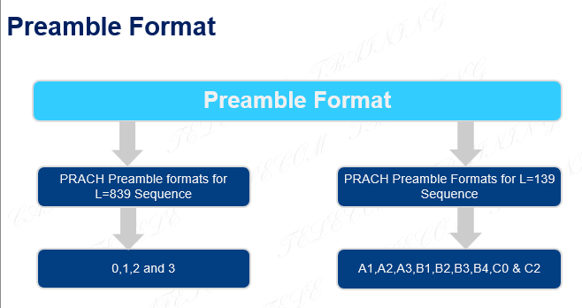

1 **Sequence Preamble format sequence L = 839**

* These formats are used for **long preamble sequences**, typically in **FR1 (sub-6 GHz) bands**.
* They have **larger subcarrier spacing (1.25 kHz, 5 kHz)** and a **longer time-domain duration**.
* Suitable for **low-speed, high-speed, normal, and weak coverage scenarios**.

**Formats 0, 1, 2, 3 (L = 839)**

Used for macro cells in FR1.

Each format has different subcarrier spacing and time duration to optimize for different scenarios.

Example:

* Format 0 (1.25 kHz) → Large cell radius (14.5 km), low speed, and high speed.
* Format 3 (5 kHz) → Ultra-high speed (trains, fast-moving UEs).

| **Format** | **Subcarrier Spacing (SCS)** | **Maximum Cell Radius** | **Use Case** |
| --- | --- | --- | --- |
| **Format 0** | 1.25 kHz | **14.5 km** | Large cell, supports both low and high speeds |
| **Format 1** | 1.25 kHz | **100.1 km** | Ultra-wide coverage, used in remote areas |
| **Format 2** | 5 kHz | **21.9 km** | Weak coverage areas with poor signal |
| **Format 3** | 5 kHz | **14.5 km** | Ultra-high speed (trains, fast-moving UEs) |

**2 L = 139 (Second Table - Formats A1 to C2)**

These formats are used for **short preamble sequences**, mainly in **FR2 (mmWave) bands**.

They have **15 kHz or 30 kHz subcarrier spacing**, **shorter time-domain duration**, and are **used for small cells or normal cells**.

Suitable for **indoor, urban, and dense network deployments**.

**Formats A1 to C2 (L = 139)**

* Used for **small cells** in FR2.
* Higher subcarrier spacing → **shorter time duration**.
* Example:
  + **A1 (0.142 ms)** → **Small cells (0.937 km radius)**.
  + **C2 (0.432 ms)** → **Larger normal cells (9.297 km radius)**.
  + **B formats** include **guard time**, making them useful for larger coverage than A formats.

| **Format** | **Maximum Cell Radius** | **Use Case** |
| --- | --- | --- |
| **A1 to A3** | Small cells (0.937 km - 3.515 km) | No guard time (GT = 0), used for small/normal cells |
| **B1 to B4** | Larger coverage (5.512 km - 8.772 km) | Increasing guard time for better coverage |
| **C0 & C1** | Long-range normal cells (up to 9.297 km) | Largest guard times for extended range |

**Thera are 2 types Preamble Format based on the length**

1.Long Preamble Format

2. Short Preamble Format

**1.Long Preamble Format**

* Sequence Length=839
* SCS=1.25 kHz or 5kHz
* FR1(sub-6) only( 410 MHz – 7125 MHz)
* Used for large cells or high speed
* 4 Formats are supported

**Formats are supported, 4 types formates**

**Format 0**

(1.25 kHz) → Large cell radius (14.5 km), low speed, and high speed.

**Format 1**

(1.25 kHz) → Ultra-wide coverage (100.1 km radius), suitable for rural or remote areas where large coverage is needed, but speed is not a priority.

**Format 2**

**(5 kHz)** → **Weak coverage (21.9 km radius)**, used in areas with **poor signal conditions** or where coverage needs to be extended without increasing transmission power.

**Format 3**

(5 kHz) → Ultra-high speed (trains, fast-moving UEs).

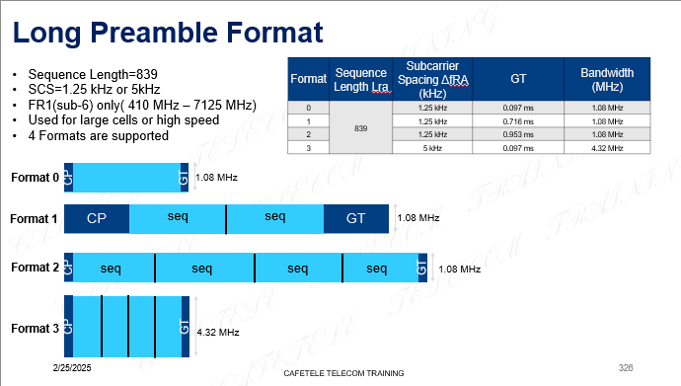

**2. Short Preamble Format**

* Sequence Length =139
* Used for limited cell radius or indoor.
* FR1 (Sub-6) – SCS 15 kHz or 30 kHz

It supports **15 kHz or 30 kHz** subcarrier spacing and is used for **wide coverage and better penetration**.

* FR2(mmw) SCS 60 kHz or 120 kHz

It supports 60 kHz or 120 kHz subcarrier spacing and is used for high-speed data transmission with low coverage.

* **9 formats are supported** 
  + **(A1 TO A3 and B1 to B4 and C0 to C1)**
  + **A1 to A3** → Have **no guard time (GT = 0)** and are used for **small and normal cells**.
* **B1 to B4** → Include **increasing guard times**, allowing for **larger cell coverage** in normal cell scenarios.
* **C0 and C1** → Have the **largest guard times**, enabling **long-range communication** in normal cells.

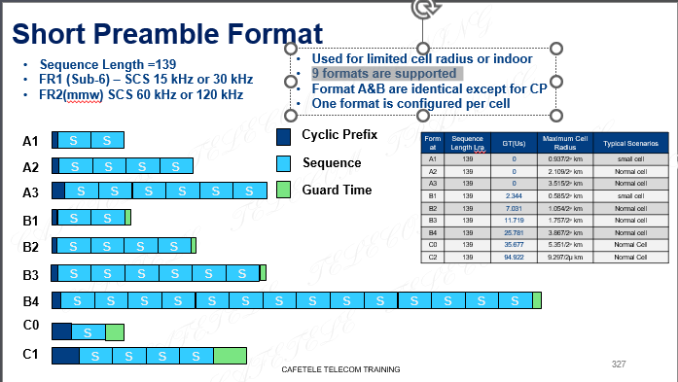

**PRACH: Time Domain Position**

PRACH Time Domain Position is the specific time when the UE can send a request to the gNB for network access.

The time domain position of the PRACH is determined by several parameters:

1. Frame Number: This identifies the specific frame in which the PRACH is located. Frames are typically 10 ms long in 5G NR.

2. Subframe Number: Each frame is divided into subframes, usually 1 ms each.

3. Slot Number: Each subframe is further divided into slots. The number of slots per subframe depends on the numerology (subcarrier spacing) used.

4. Occasion Number: This refers to the specific PRACH occasion within the slot. Multiple PRACH occasions can exist within a single slot.

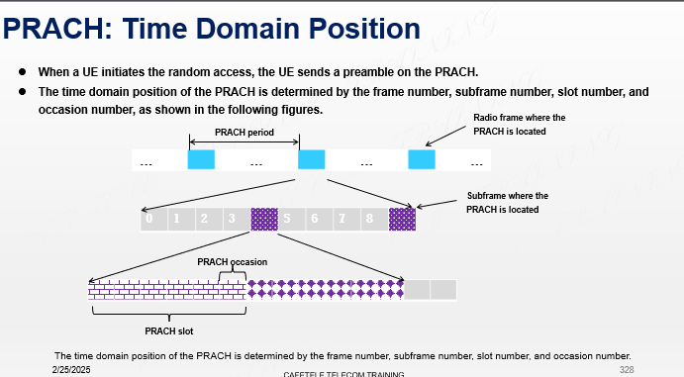

**PRACH: Frequency Domain Position**

839 and 139 refer to long sequence and short sequence PRACH formats, respectively.

Long sequences (839 samples) are typically used for FR1 (Frequency Range 1, below 6 GHz).

Short sequences (139 samples) are often used in FR2 (mmWave, above 24 GHz).

PRACH SCS (Subcarrier Spacing):